INSTRUCTIONS FOR PREPARING YOUR EXTENDED ABSTRACT
FOR THE 19th ANNUAL CMAS CONFERENCE

Brian F. Naess*
Institute for the Environment, The University of North Carolina, Chapel Hill, NC, USA

John Q. Modeler and Jane X. Policymaker
U.S. Environmental Protection Agency, Research Triangle Park, NC, USA

1. INTRODUCTION

To properly prepare your extended abstract manuscript, please adhere to the following instructions. You can use the Word soft copy of this instructions file as a formatting template. Please remember that your abstract must be in final form when you submit it to us; it will not be reviewed or edited. Copies of the extended abstracts will be posted on the conference web site.

2. MANUSCRIPT SUBMISSION PROCEDURE AND DEADLINE

Your submitted manuscript must be in PDF format. Please e-mail it to cmas@unc.edu. Use “Conference extended abstract” as your e-mail’s subject line.
Please try to send us your manuscript by October 26, 2020, but no later than December 1, 2020.

3. LENGTH OF ABSTRACT

The abstract, including figures, tables, and references, should be no more than six (6) pages.

4. PAGE LAYOUT AND TEXT FONT

Your extended abstract should be formatted for a paper size of 8½” x 11” (216 mm x 279 mm). Margins on all sides should be 1”. Please use 10-point Helvetica, Arial, or similar font for the text.
Place the text in newspaper-style columns with a ¼” space between columns. If necessary, figures and tables may span the two columns, as long as they still adhere to the 1” outside margins.
Please center page numbers at the bottom of the page.

5. MANUSCRIPT FORMATTING

5.1 Title and Author Information

The title of the extended abstract should be centered and typed in BOLD CAPITAL LETTERS in 11-point type on the first line of your manuscript. Type the names of all authors in 11-point type (not bolded) and center them on the page beginning two lines below the title. Type an asterisk right after the name of the corresponding author. In 10-point type, enter each author’s organizational affiliation, city, state, and country, and center that information on the line below the name.

5.2 Section Headings

All headings in the body should be Arabic-numbered. Put first-level headings in 11-POINT BOLD CAPITAL LETTERS. Second-level (x.x) headings should be in 11-Point Bold Italic and use title-style capitalization. Third-level (x.x.x) headings should be in 10-point bold and use sentence-style capitalization.

5.3 Footnotes

Within the 1” margins, please type the corresponding author’s contact information in an asterisked, 9-point note at the lower left corner of your first page. Include mailing address and e-mail address, plus a web site if desired.
Any other footnotes should be prepared using superscripted Arabic numbers.

5.4 References

List all bibliographical references at the end of the abstract in alphabetical order by first author. When referring to them in the text, type the corresponding author surname(s) followed by the year of publication—for example, O’Possum and Platypus (1984). Please use the referencing style from any of the American Meteorological Society (AMS) journals, which is explained in brief on p. 3 of https://www.ametsoc.org/index.cfm/ams/publications/authors/journal-and-bams-authors/formatting-and-manuscript-components/references.

5.5 Equation Numbers

Enclose Arabic, sequential equation numbers in parentheses and place them flush with the right-hand margin of the column.
For illustration, the circumference of a circle is defined by

c=2πr (1)

where c is the circumference of the circle, r is the radius of the circle, and the value of π is defined to be approximately 3.14159265358.

6. UNITS

The International System of Units (SI units) should be used in all manuscripts.

7. FIGURES AND TABLES

Each figure or table must be cited in the text. They should be sized so that they can be embedded in the text in the area where each one is first cited (rather than grouped together at the end of the abstract). Captions are required and should be typed in 9-point type below figures or in 10-point type above tables. Note that even though your body text is in 10-point type, it is fine to put your tables in 9-point type if needed to make them better fit the page. If you have room, it’s helpful to readers to put extra white space above and below each table+caption or figure+caption, to separate them more clearly from the surrounding text.
A table or figure that cannot be placed in the same orientation as the text should be rotated 90º counterclockwise so that the figure and caption can be read by rotating the manuscript 90º clockwise.
An example figure is given in the next column.
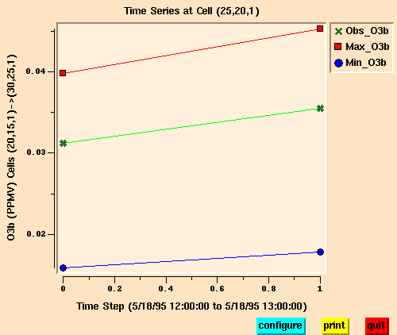
Fig. 1. Time series plot of observed ozone concentrations at grid cell (25,20,1) compared with maximum and minimum modeled variable ozone concentrations.

8. DO YOU HAVE QUESTIONS?

If you have any questions about these instructions or this template, please contact Brian Naess at 919-966-9925 or naess@unc.edu.

Please adhere to the due date of
October 26, 2020. Thank you!

*Corresponding author: Brian F. Naess, Institute for the Environment, UNC-Chapel Hill, 304 Whitehead, CB 1105; Chapel Hill, NC 27599-1105; e-mail: naess@unc.edu [Note to authors (delete this after reading it): To make sure this footnote works properly, please do not delete the “1.” at the beginning of the first section heading (currently “1. INTRODUCTION”), although of course you may change the text of that heading as needed.]

